Project Databases Report

Spotify System

Teacher:

Student: Jinghong Miao [jm7012@nyu.edu](mailto:jm7012@nyu.edu)

Executive Summary

Design a database-backed website for a music streaming service similar to Spotify. The website can provide users with information about artists and songs and albums. And users can follow any other users and like artists.

The website allows users to sign up, choosing a unique user name and provide some basic information likes real name, email and city. Real name, email and city can be provided after signing up. But the username and password can’t include any symbols in order to guard against SQL injection and cross-site scripting attacks.

After signing up, the user can search any information including user, artist, track, album and playlist by searching bar. And user can follow others, play tracks, like artists and look through other user’s following, likes and playlists if the playlist authorization allows others to view the list.

According to recent activities that are relative to the user, the user can see a feed of items like some new tracks composed by artists that the user likes.

Also, the use can unfollow uses, unlike artists or delete their own playlist.

GUP Specification

The GUI is web-based and use web-based technologies such HTML, JavaScript, jQuery and PHP in combination with images to display pages.

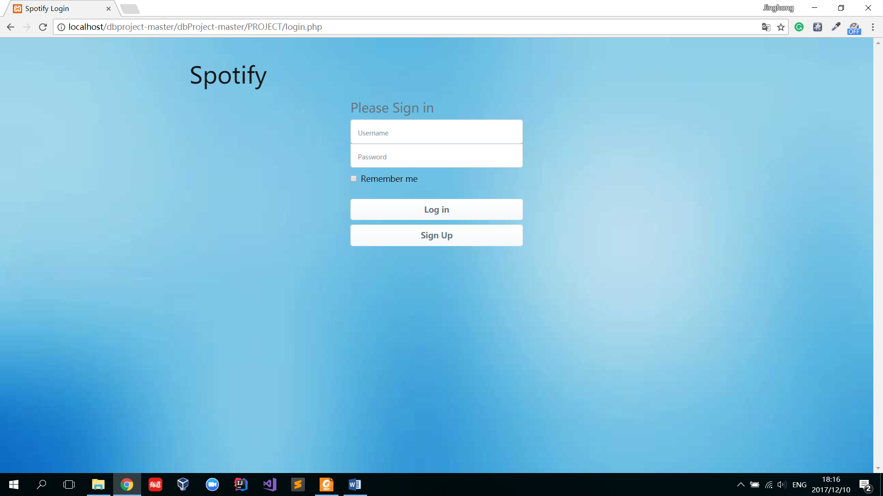

Fig 1. Login page

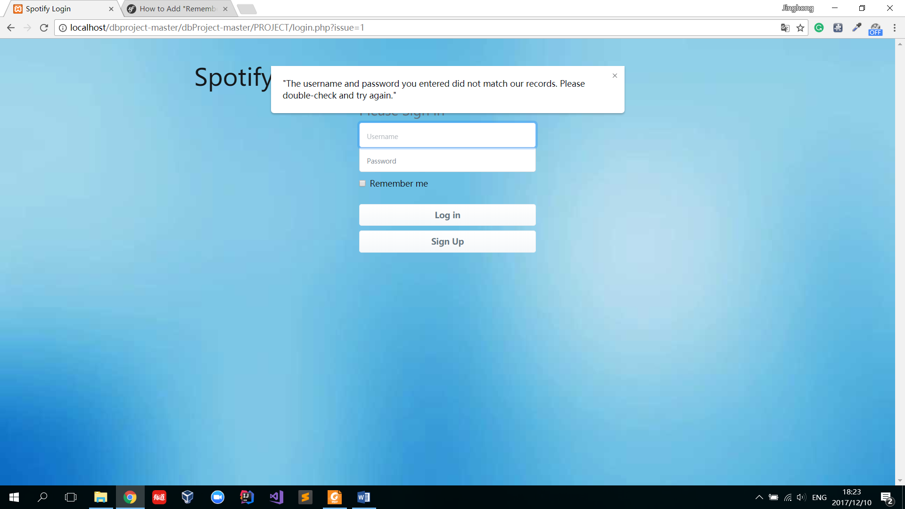

Fig 2.

Fig 1 shows the first page for users. In the middle of the page are username and password filling in form for those who has already signed in. After filling in username and password, clicking “Log in” button will post the username and password information to backend. If the username and password fits the information stored in backend database, the user can enter his own homepage. If the username or password is incorrect, the user will stay at the same page with a alert for “incorrect username or password”, as shown in Fig 2.

The” Sign Up” button enables user to register in the website.

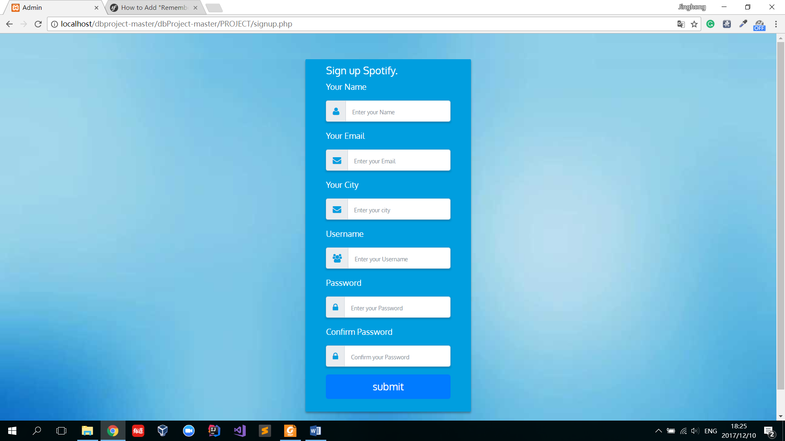

Fig 3.

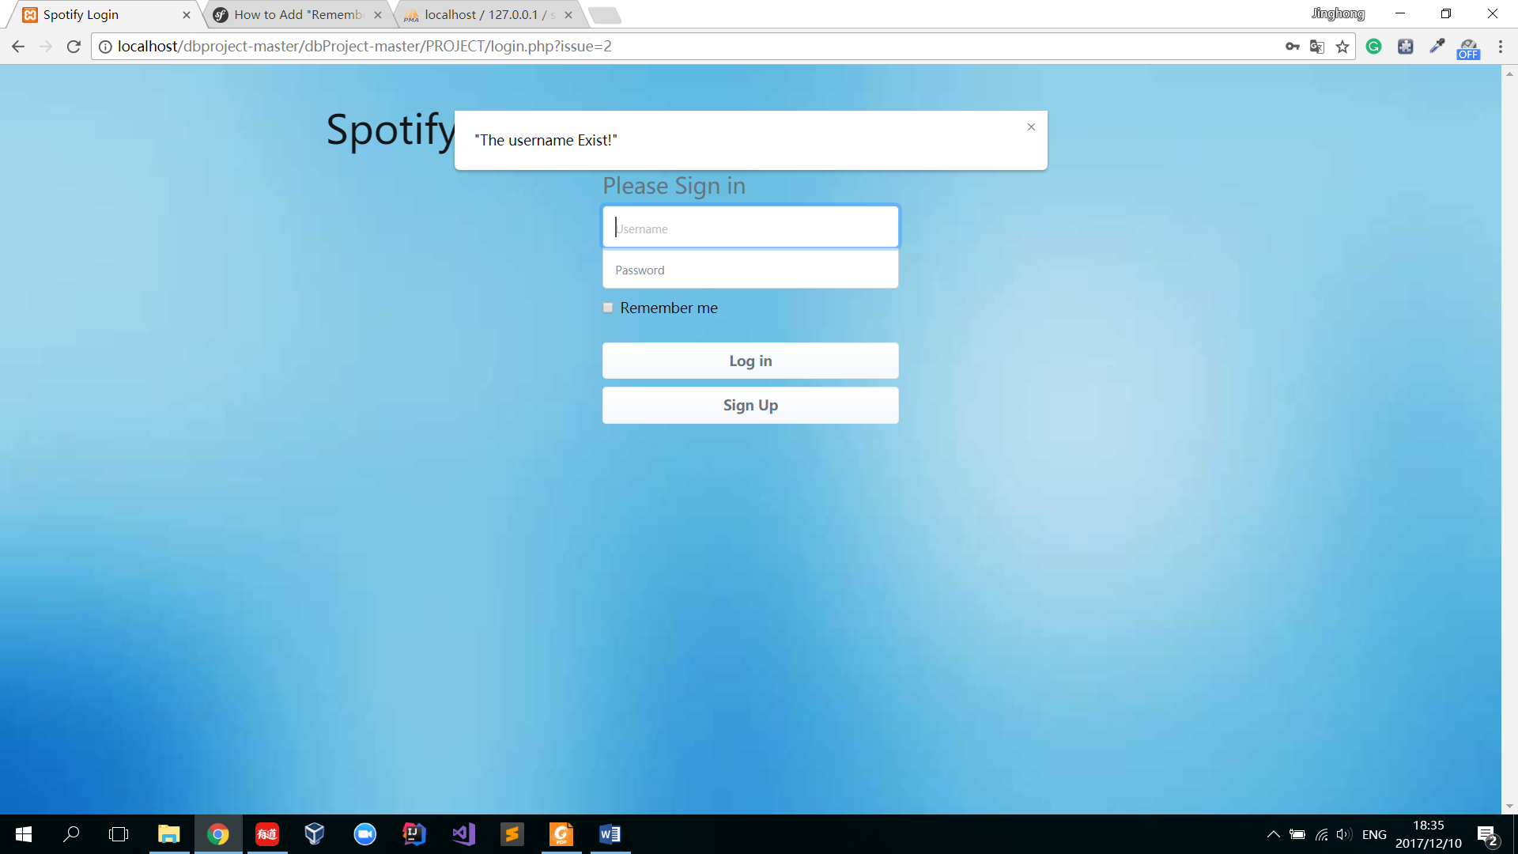

Fig 4.

Fig 3 shows the registering/ signing up webpage. The main part of the page is a form which record information from user. “Your name” is to record the user’s Real Name. “Your Email” is to record the user’s Email. “Your City” is to record the user’s city. “Username” is to record the user’s unique username, which is also the identification for the user in the database.

“Password” is to record the user’s password for log in. “Confirm Password” is to record the user’s second typing password in order to make sure the user typing the correct password that they want. In the above information, username and password is necessary. User can’t submit this information if the username or password is blank. Also, the webpage will check if the password is the same as confirm password. If these two passwords is not the same, an alert will remind user to double check their input.

If the username is taken by other user, the webpage will also tell user to type another unique username in sign in page in the case that user forget registering, as shown in Fig 3.

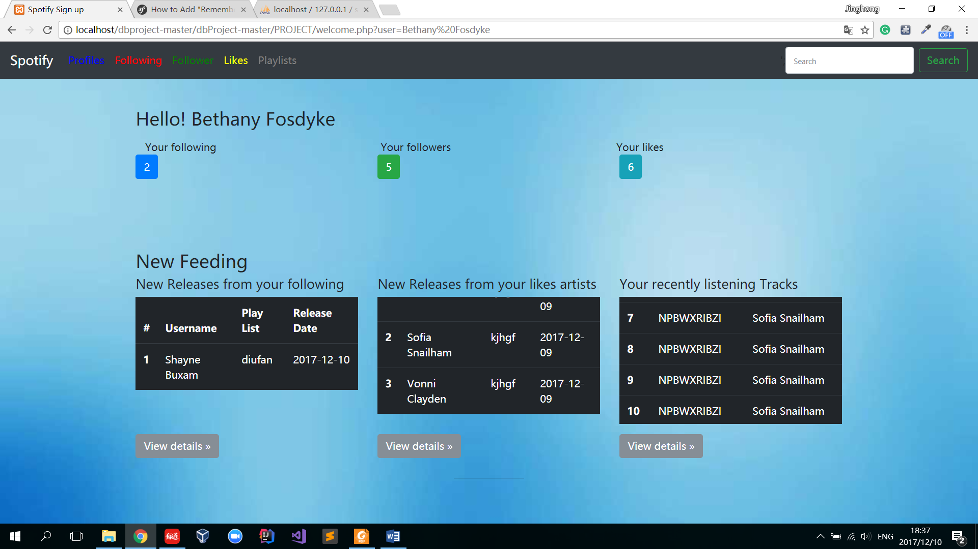

Fig 5.

If all information that user types valid in the backend database, use will be redirect to the welcome page, as shown in Fig 5.

At the top of the webpage, there is a navigation bar. A Spotify symbol on the left side, clicking the button will redirect the user back to the welcome page. The profiles button will allow user to see their own profile. Clicking Following button will allow user to see their own following user table. Clicking Follower button will allow user to see who is following them. Clicking Likes button will allow user to see those artists that he/she likes. Clicking Playlists button will allow user to looking through their own playlists. On the right corner of the webpage is a search table for user to search anything in the database, including user, artists, tracks, playlists and albums.

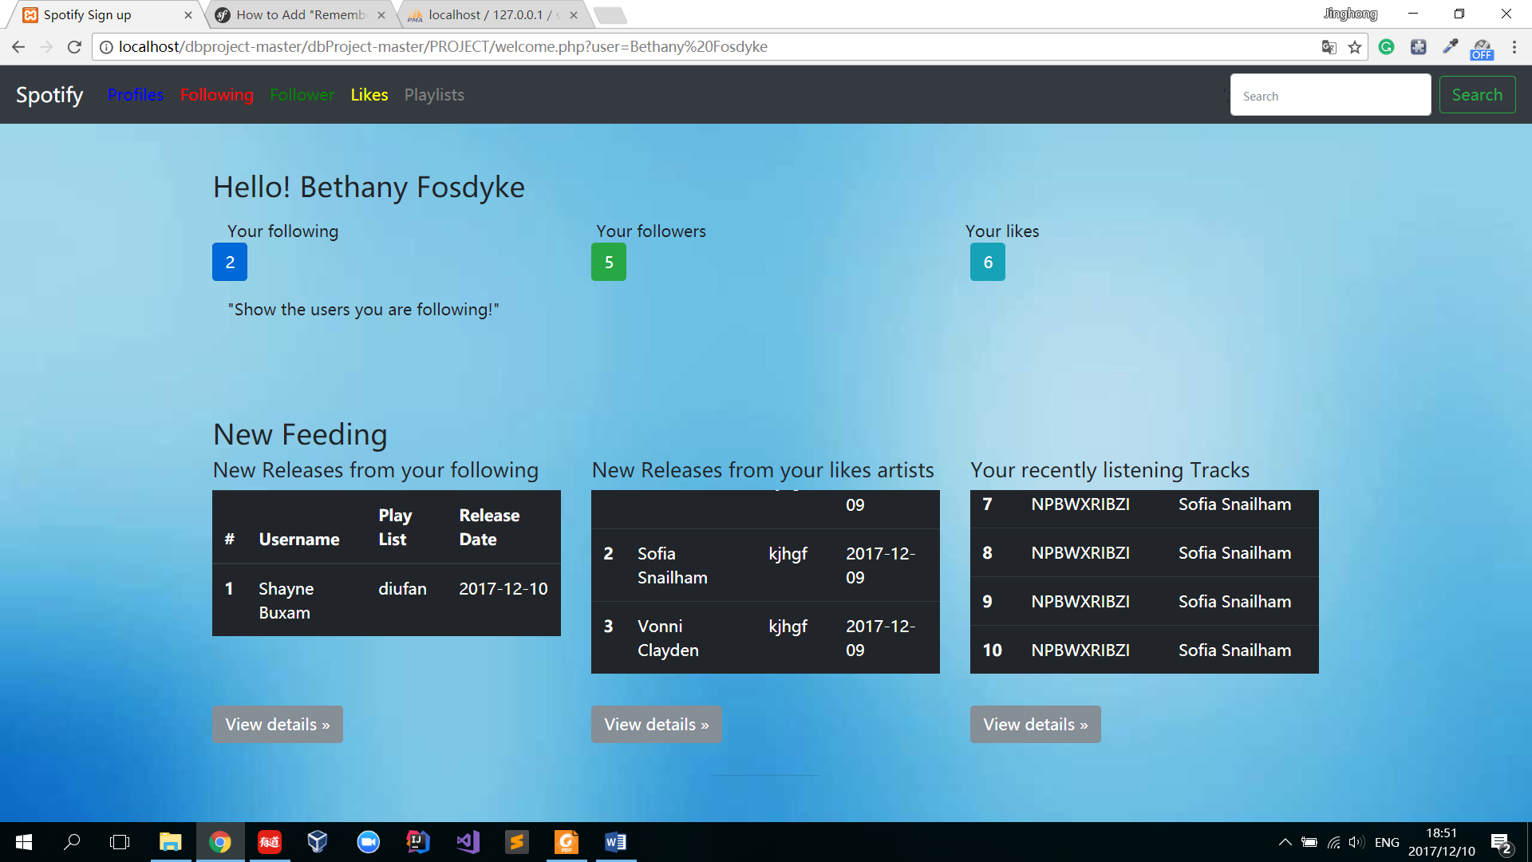

Figure 6.

In the middle of the webpage is a text “Hello!” along with the username. Under the text is three texts and numbers. Hovering the pointer on each button will show what the button meaning, as shown in Fig 6. “your following” number means how many users the user is following; “Your followers” number means how many users is following the user; “Your likes” number means how many artists the user is liking. These number is according to the backend database.

Beneath these buttons is feeding for the user. The first scrolling down list is the playlist created by other users that the current user following. In these case, there is only has 10 records. If the user wants to see the full information, he/she can click “View details” under the table. The second scrolling down list is the track created by artists that the current user likes. In these case, there is only has 10 records. If the user wants to see the full information, he/she can click “View details” under the table. The third scrolling down list is the track history which the users listened before. In these case, there is only has 10 records. If the user wants to see the full information, he/she can click “View details” under the table.

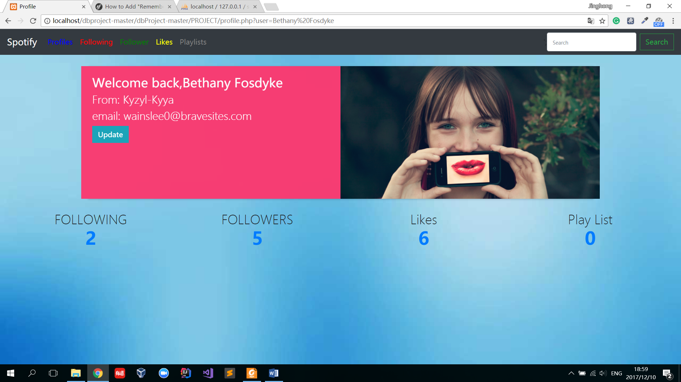

Figure 7.

Figure 7 is the profile for user. The navigation bar on top of the webpage which is the same as that in welcome page as introduced before.

In the middle of the page is a space to show the user’s detail information, in this case, there is a welcome back text with the user’ username. Under the text is the user’s city and email. The green update button allows user to update their profiles. Next to those information, there is a user picture (default all the user pictures are the same).

In the bottom part of the page, the following number, followers number, likes number and play list number are shown. User can click the numbers to view details.

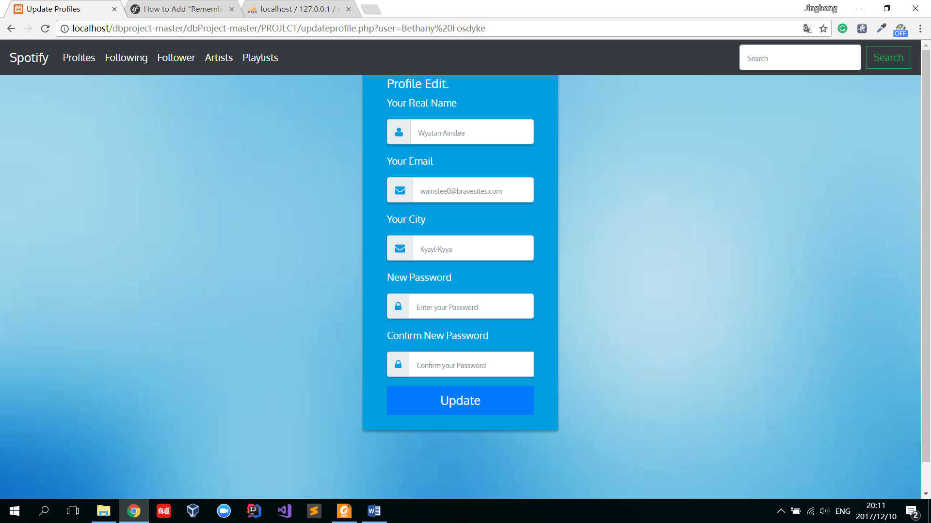

Figure 8.

Fig 8 is the profile update webpage. In the webpage, user can edit their real name, email, city and password. Not all information is necessary, user can choose which part of information they are willing to change. When the user finish inputting, clicking update button will post their updated information in the database and edit. Same, the new password and confirm new password should be same, the real name, city and password can’t include any symbols for the security issues.

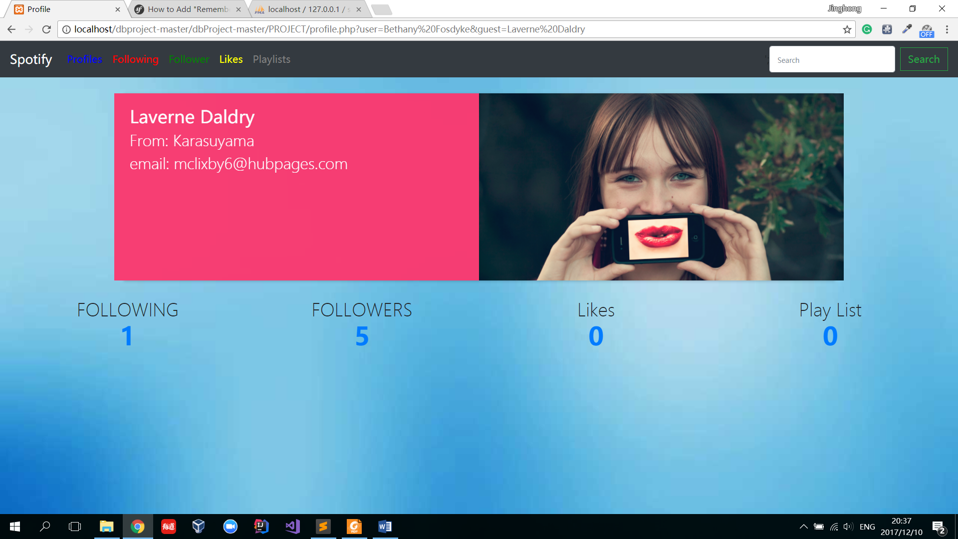

Figure 9.

Fig 9 is the webpage when one user is views the other’s profile. The only different is that user can’t edit others profile. So the “update” button is hidden. But user can view other’s following, followers, likes and playlist.

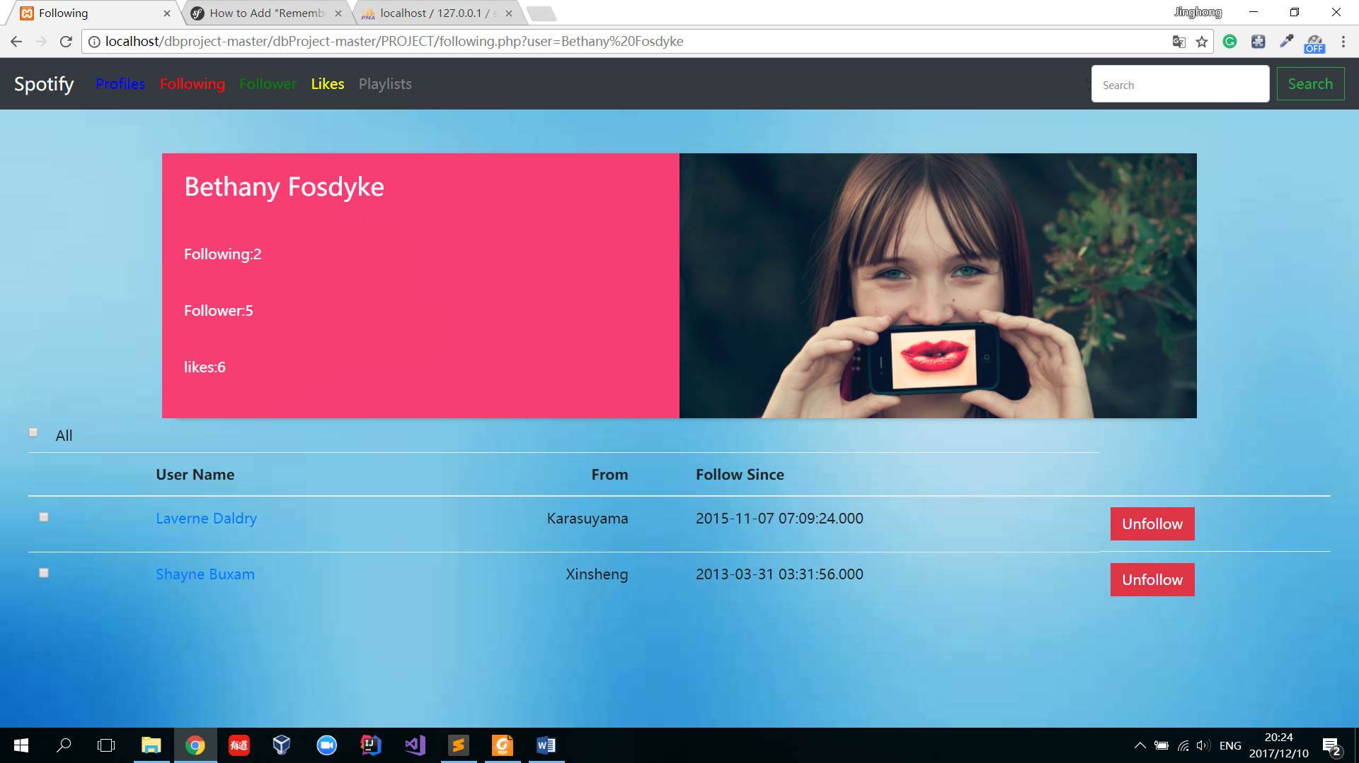

Figure 10.

Figure 10 is the user following page. The navigation bar and profile are the same as before. The rest part of the page is a list showing users that the current user is following. The information includes username, city and the date that the user starts to follow.

The user can click those usernames to view those users’ profiles, following, playlists and likes.

The user can click “unfollow” button to cancel the follow relation. If the user wants to unfollow multiple relation, he can check the box on the left of each username. Also, the “All” checkbox will select all users he/she is following. If any user is checked, a “unfollow checked” button shows up to make it more convenient for user to unfollow. As shown in Figure 11.

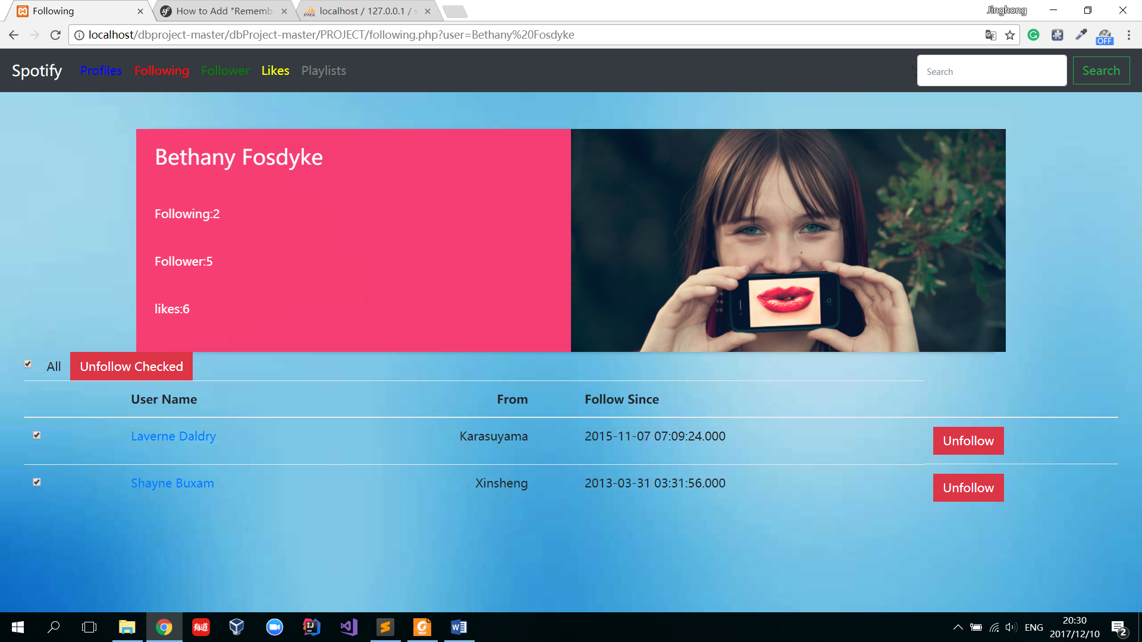

Figure 11.

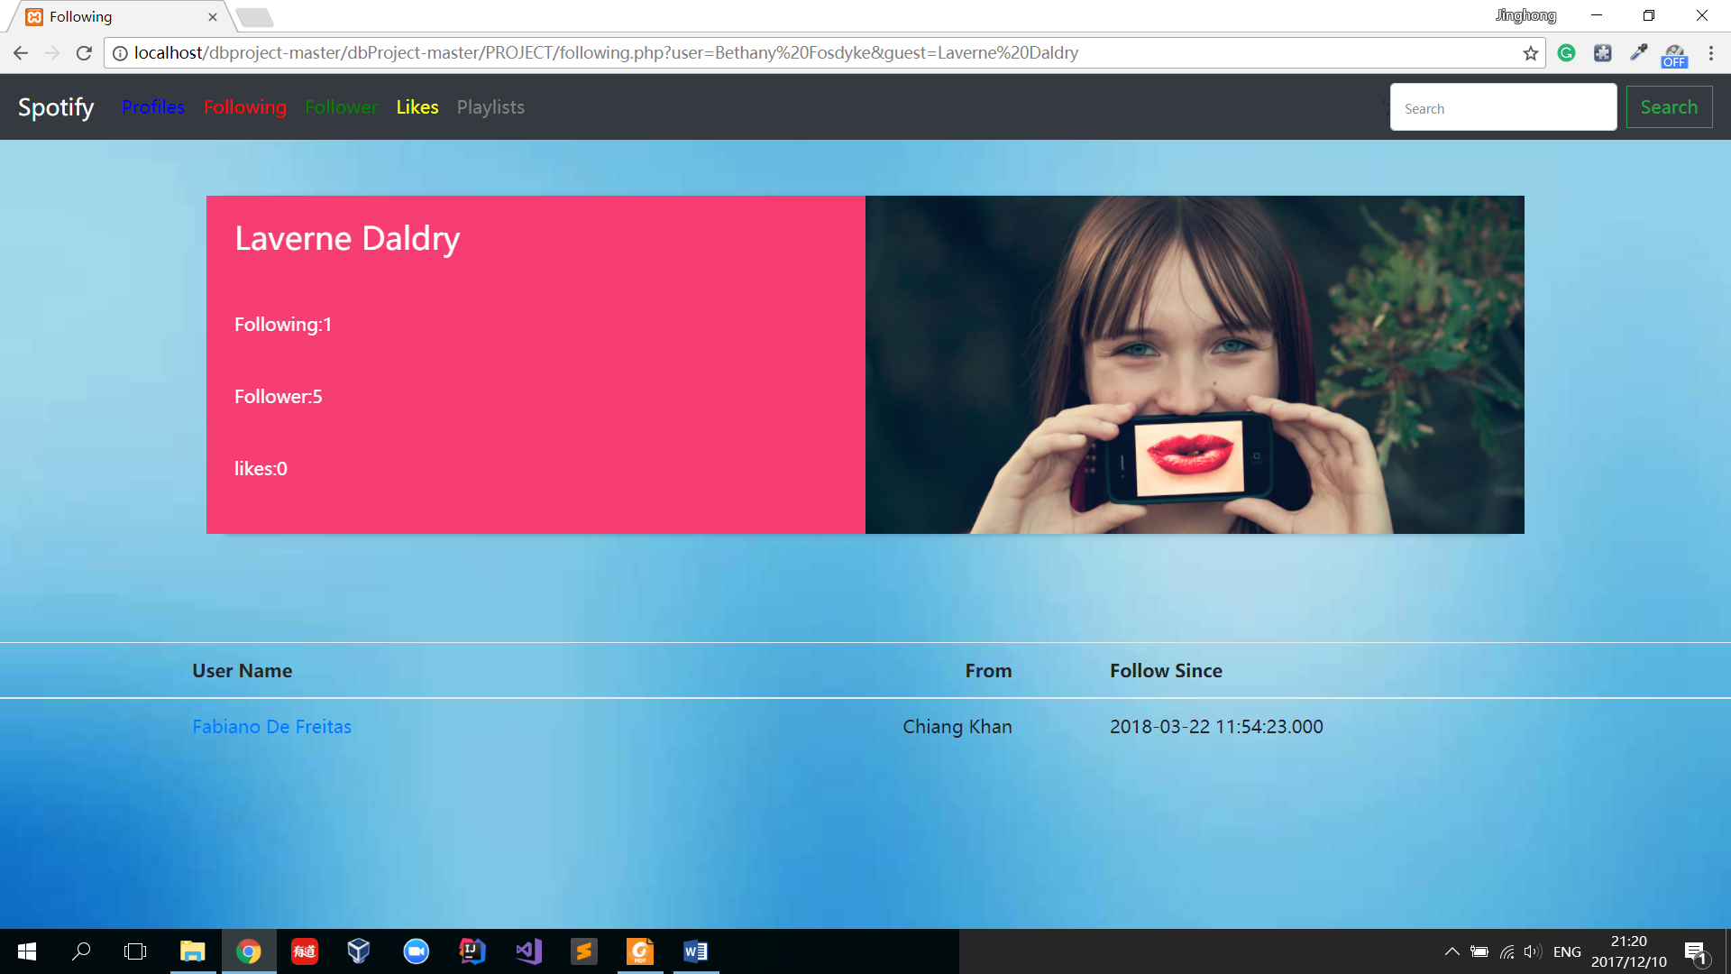

Figure 12.

Fig 12 is the webpage when one user is views the other’s following list. The only different is that user can’t delete others following. So the “Unfollowing” button is hidden.

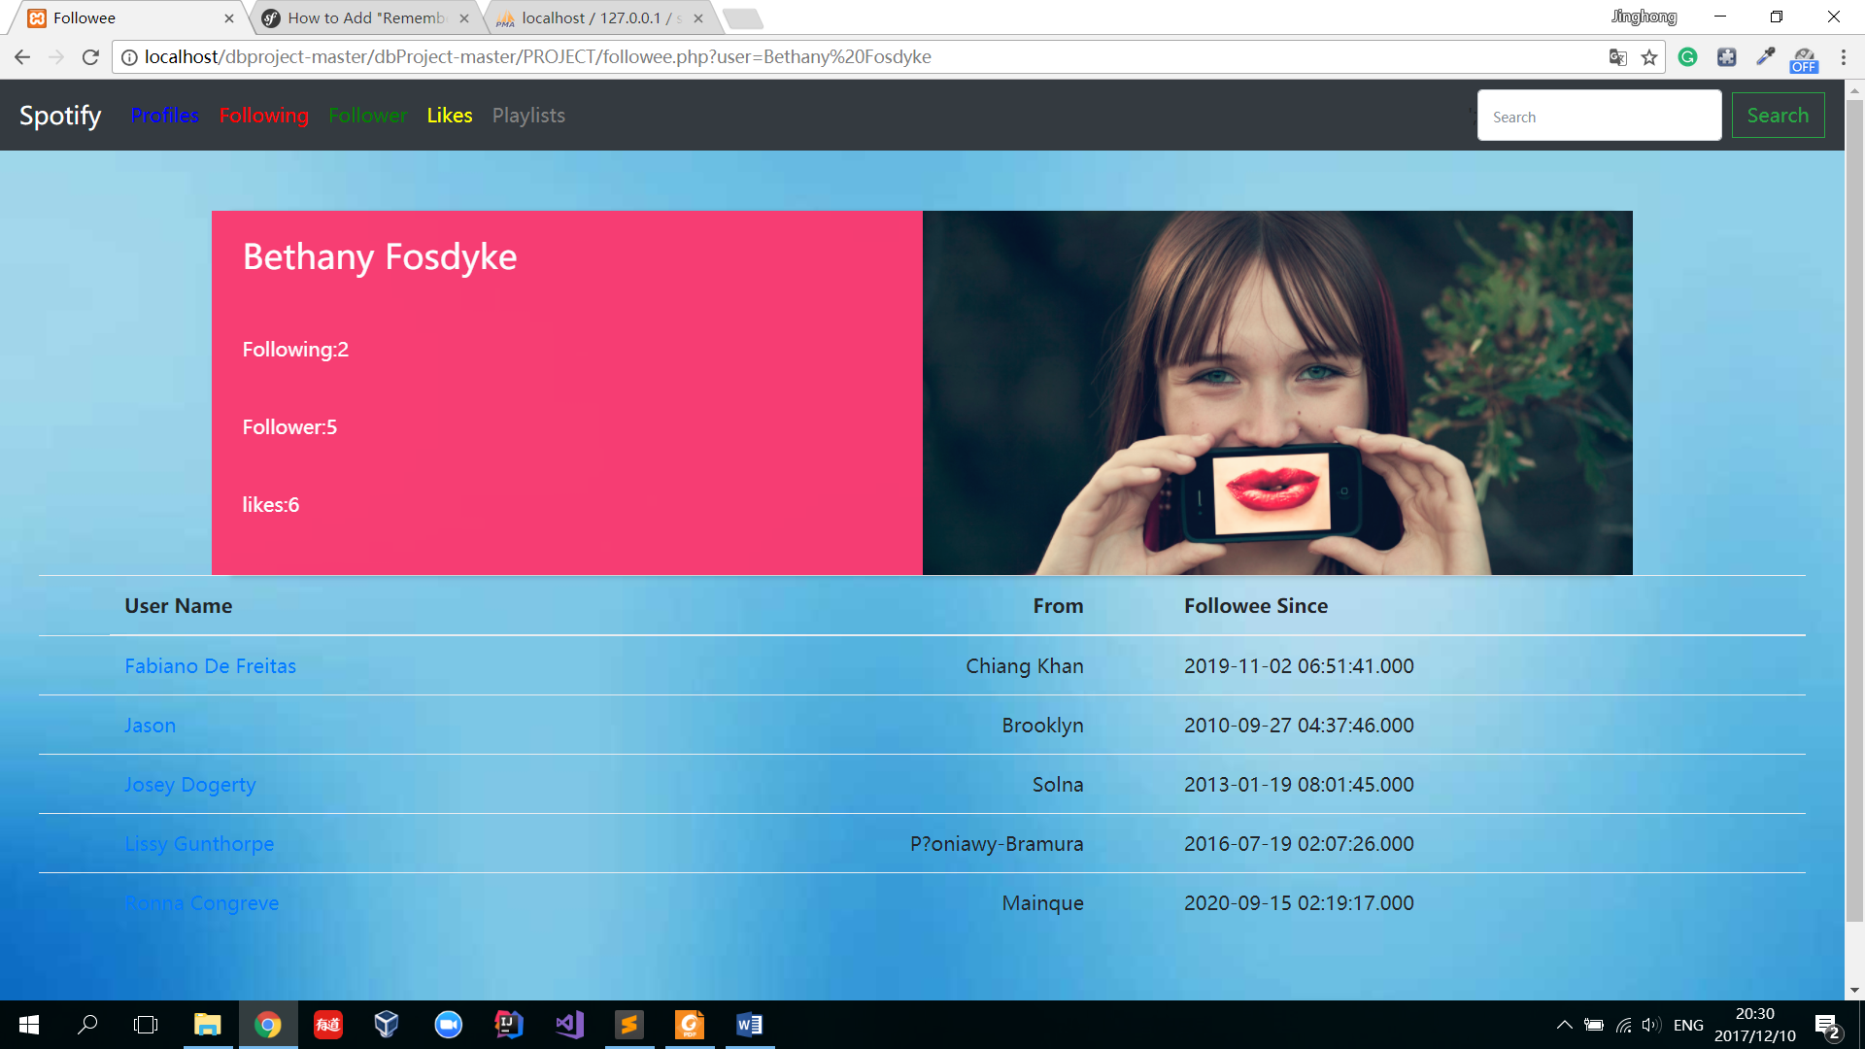

Figure 13.

Fig 13 is the user followed page. The layout is the same as following webpage excepts the content of the table. Here the table shows which users is following the user. But they can’t stop following relation here because the decision is made by other users. Also, they can also click other’s name to view profiles.

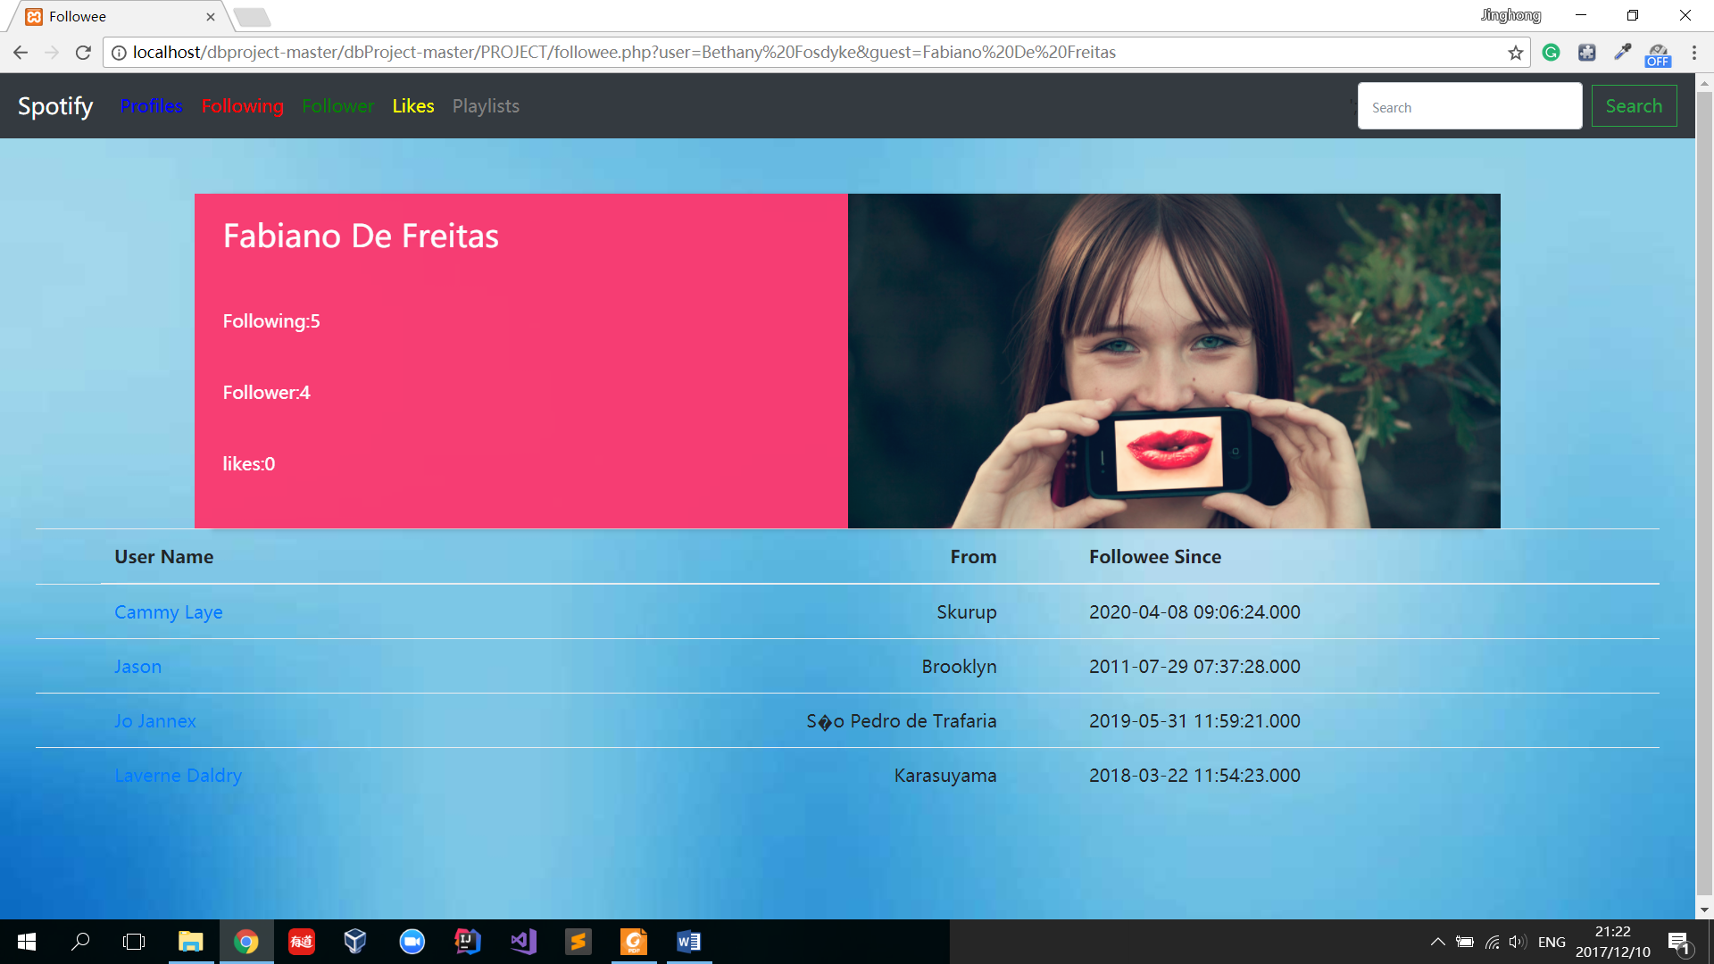

Figure 14.

Fig 14 is the webpage when one user is views the other’s followed list.

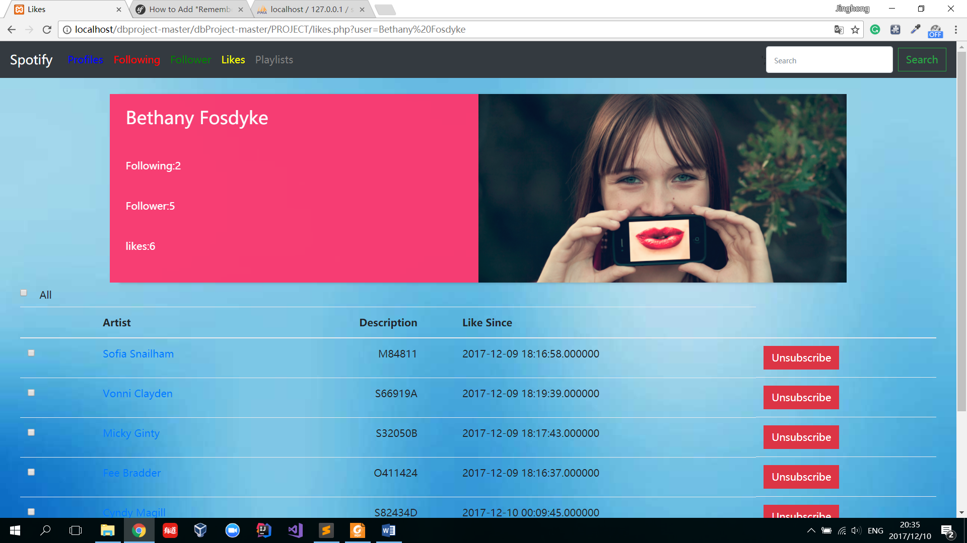

Figure 15

Fig 15 is the likes page. The layout is the same as following and follower webpage excepts the content of the table. Here the table shows which artists is liking. The unsubscribe button can stop liking. Also, they can also click artists’ names to view profiles.

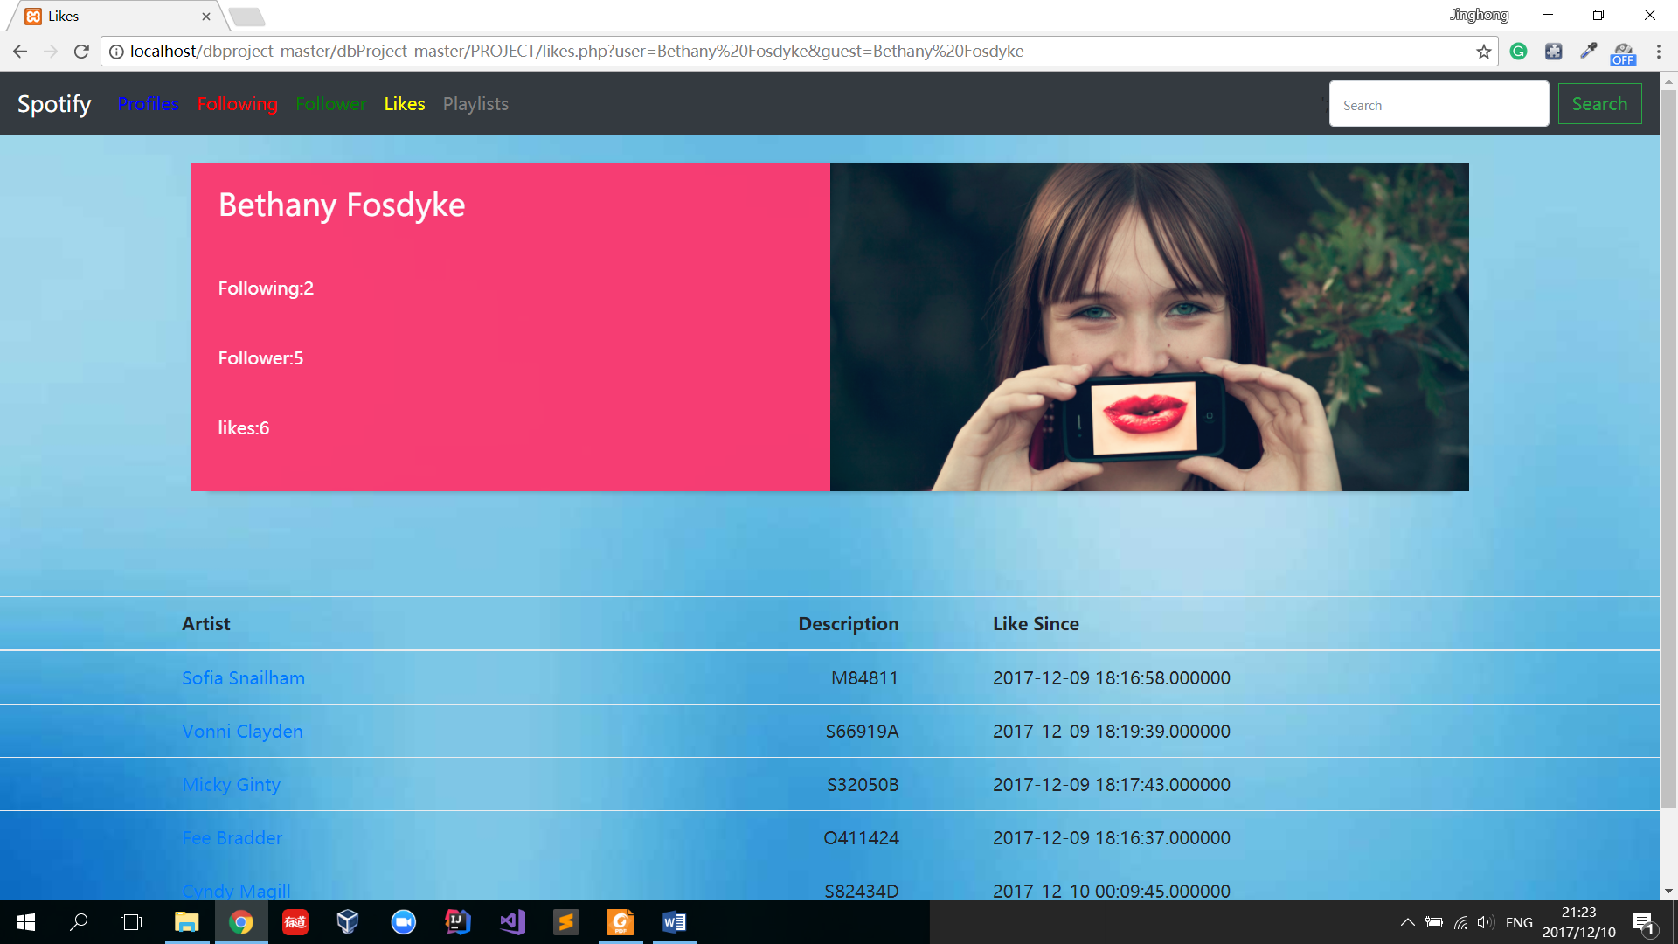

Figure 16

Fig 16 is the webpage when one user is views the other’s like list. The only different is that user can’t delete others liking. So the “Unsubscribe” button is hidden.

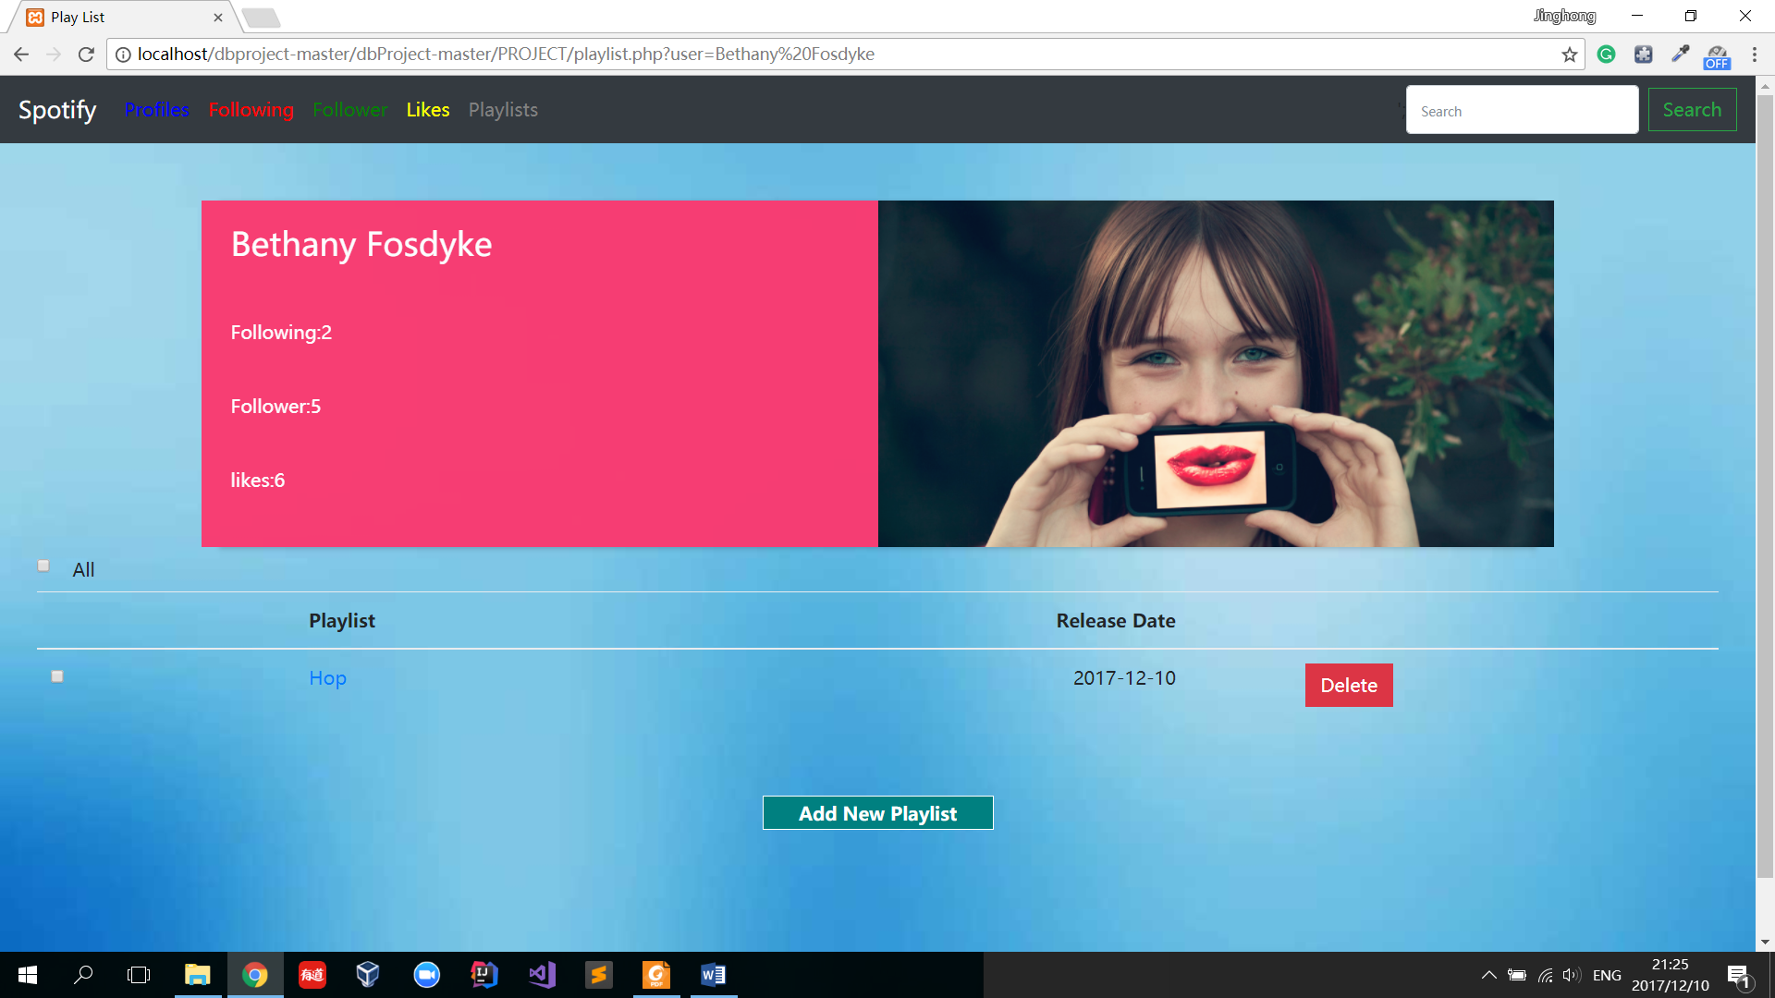

Figure 17

Fig 17 is the user’s playlist page. The layout is the same as following and follower webpage excepts the content of the table. Here the table shows all the user’s playlist. The delete button can delete the whole playlist whatever there are tracks in the playlist or not. Also, they can also click playlists’ names to view profiles.

